Eigen Values and Eigen Vectors with Visualization

EXPERIMENT-1

FOR 2X2 MATRIX : -

clc

A = input('Enter a 2\*2 matrix');

[P,D] = eig(A)

t = linspace(0,1,500);

plot(P(1,1)\*t,P(2,1)\*t,'blue')

hold on

plot(D(1,1)\*P(1,1)\*t,D(1,1)\*P(2,1)\*t,'y')

hold on

plot(P(1,2)\*t,P(2,2)\*t,'r')

hold on

plot(D(2,2)\*P(1,2)\*t,D(2,2)\*P(2,2)\*t,'black')

Input 1: -

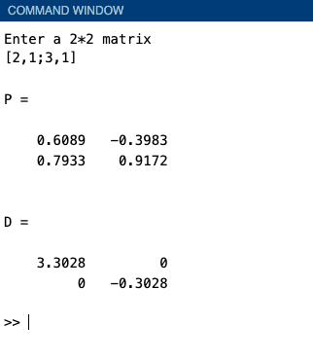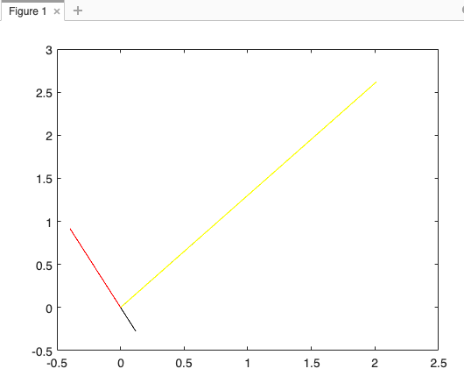

Input 2: -

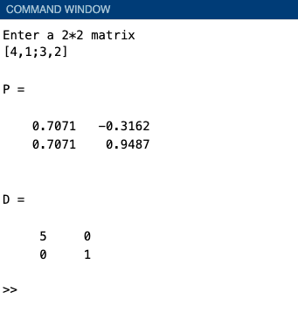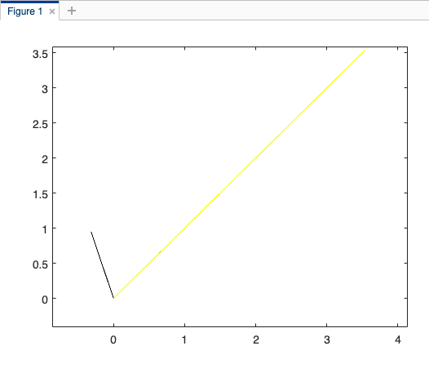

FOR 3X3 MATRIX : -

clc

clear all

A = input('Enter a 3\*3 matrix');

[P,D] = eig(A)

t = linspace(0,1,500);

plot3(P(1,1)\*t,P(2,1)\*t,P(3,1)\*t,'blue')

hold on

plot3(D(1,1)\*P(1,1)\*t,D(1,1)\*P(2,1)\*t,D(1,1)\*P(3,1)\*t,'y')

hold on

plot3(P(1,2)\*t,P(2,2)\*t,P(3,2)\*t,'r')

hold on

plot3(D(2,2)\*P(1,2)\*t,D(2,2)\*P(2,2)\*t,D(2,2)\*P(3,2)\*t,'black')

hold on

plot3(P(1,3)\*t,P(2,3)\*t,P(3,3)\*t,'g')

hold on

plot3(D(3,3)\*P(1,3)\*t,D(3,3)\*P(2,3)\*t,D(3,3)\*P(3,3)\*t,'m')

Input1: -

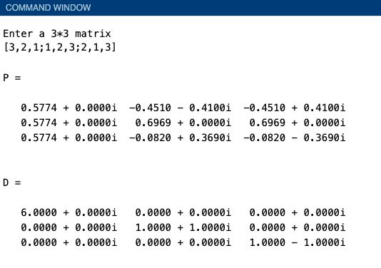

Figure: -

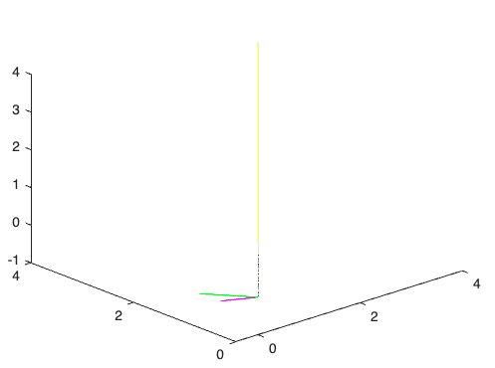

Input 2 : -

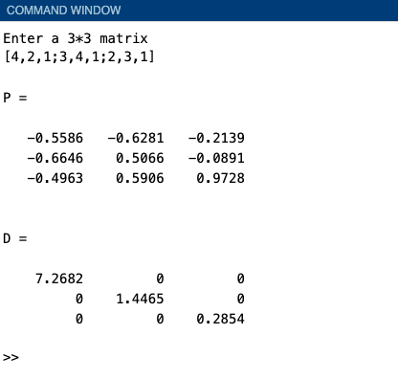

Figure: -

